Meeting Documentation Report
Video: videoplayback (1).mp4
Scene Changes: 25 | Audio Segments: 15
Content Type: Speech detected
--------------------------------------------------

Key Discussion Points
• 0.0s: When every choice echoes across a million worlds, some faces return changed.
• 7.0s: Reality is a pattern. I will redesign it.
• 16.0s: We hold the line, not hand it over.
• 19.0s: He's not just a man. He's an end.
• 23.0s: We are not intruders. We are a response.

Detailed Timeline

4.5s
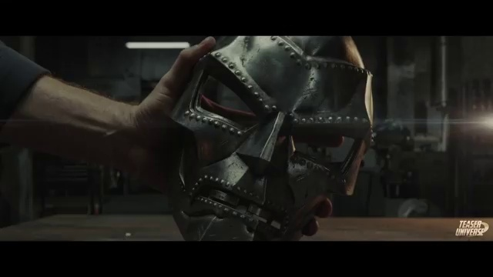
Transcript: Reality is a pattern. I will redesign it.
Scene Change: Visual content changed at this timestamp

7.2s

Transcript: Reality is a pattern. I will redesign it.
Scene Change: Visual content changed at this timestamp

12.2s
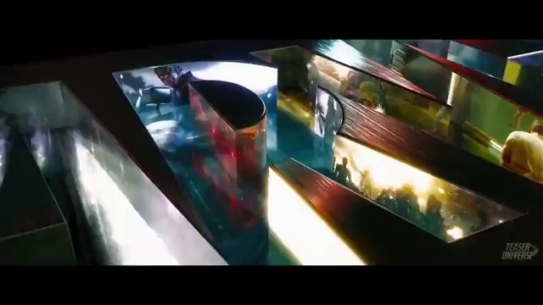
Transcript: [No speech at this timestamp]
Scene Change: Visual content changed at this timestamp

16.0s
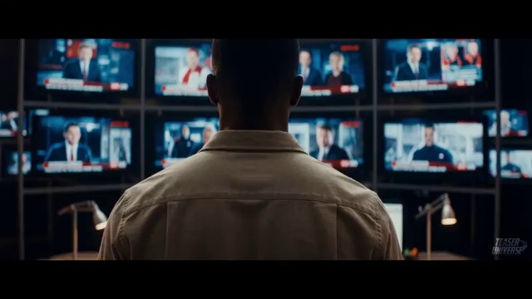
Transcript: We hold the line, not hand it over. He's not just a man. He's an end.
Scene Change: Visual content changed at this timestamp

19.6s
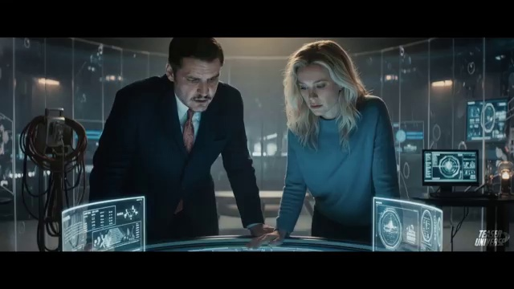
Transcript: He's not just a man. He's an end.
Scene Change: Visual content changed at this timestamp

23.1s
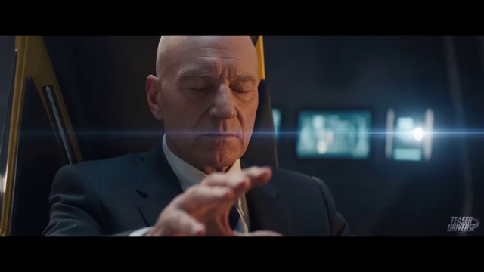
Transcript: We are not intruders. We are a response.
Scene Change: Visual content changed at this timestamp

26.7s
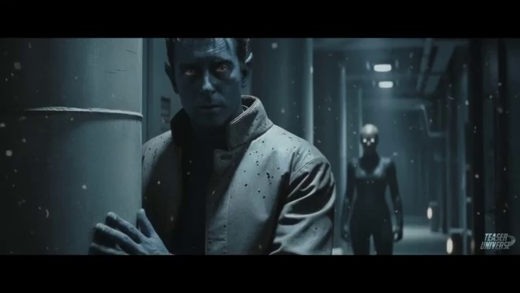
Transcript: We fail.
Scene Change: Visual content changed at this timestamp

28.9s
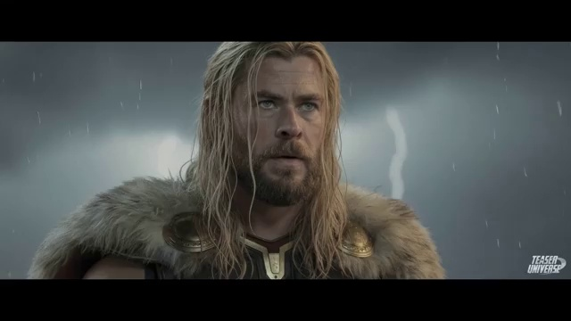
Transcript: We fail. Everything dies.
Scene Change: Visual content changed at this timestamp

30.2s

Transcript: We fail. Everything dies. Order must be engineered.
Scene Change: Visual content changed at this timestamp

32.5s
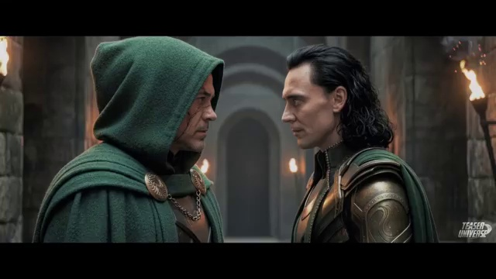
Transcript: Everything dies. Order must be engineered.
Scene Change: Visual content changed at this timestamp

36.1s
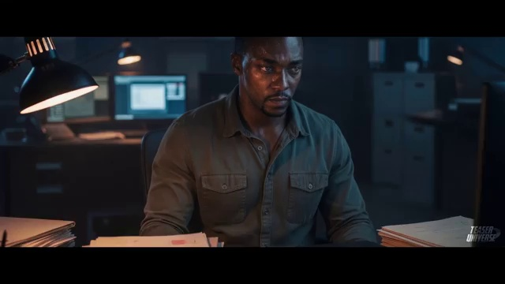
Transcript: We either stand together or fall apart.
Scene Change: Visual content changed at this timestamp

38.8s
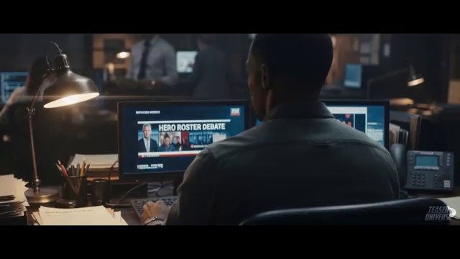
Transcript: We either stand together or fall apart. He'll make a god of himself.
Scene Change: Visual content changed at this timestamp

40.4s
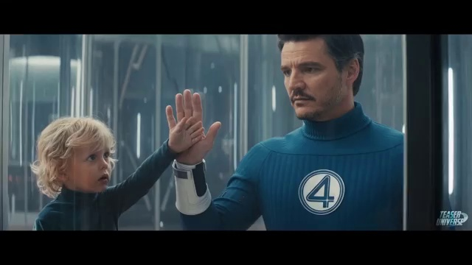
Transcript: He'll make a god of himself.
Scene Change: Visual content changed at this timestamp

43.2s
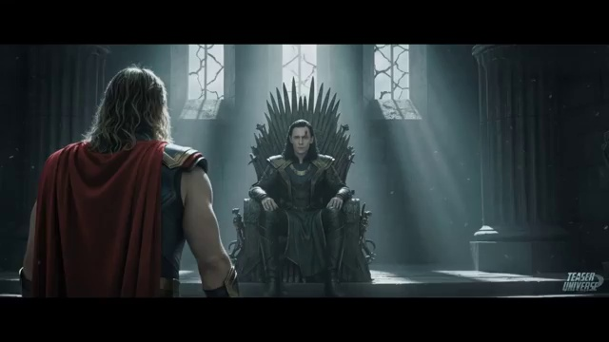
Transcript: You never listen, brother. Hold your thoughts. Hold your hope.
Scene Change: Visual content changed at this timestamp

44.5s
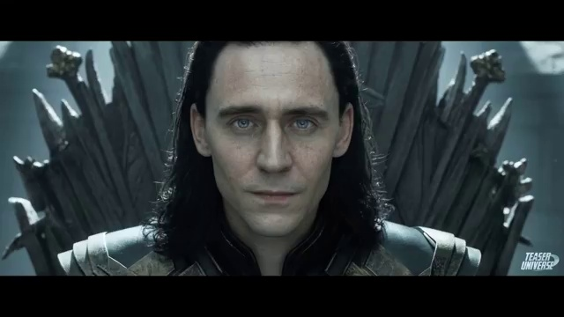
Transcript: You never listen, brother. Hold your thoughts. Hold your hope.
Scene Change: Visual content changed at this timestamp

46.6s
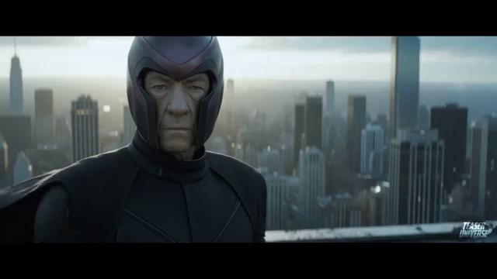
Transcript: You never listen, brother. Hold your thoughts. Hold your hope.
Scene Change: Visual content changed at this timestamp

48.6s
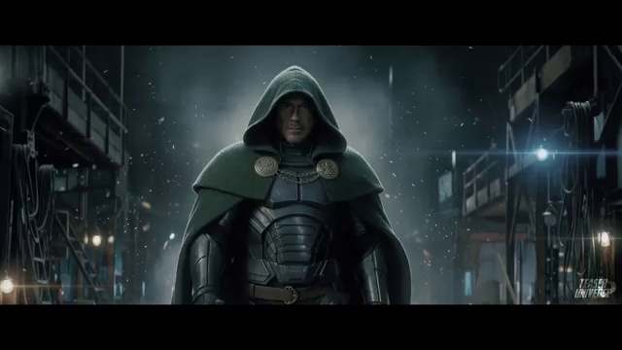
Transcript: Hold your thoughts. Hold your hope. Chaos is an old friend.
Scene Change: Visual content changed at this timestamp

50.2s
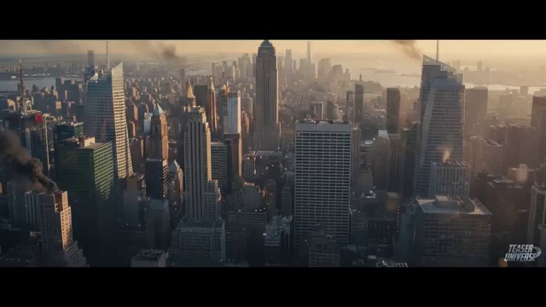
Transcript: Chaos is an old friend. Then let's greet it together.
Scene Change: Visual content changed at this timestamp

51.8s
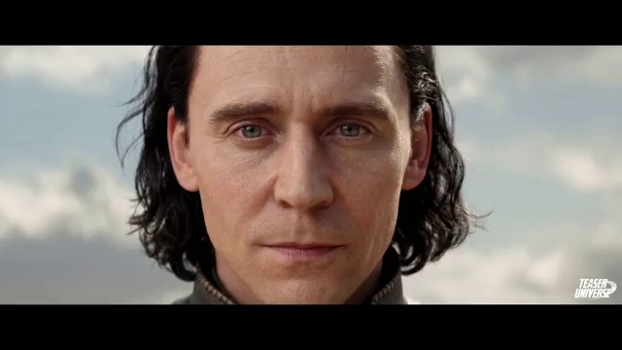
Transcript: Chaos is an old friend. Then let's greet it together.
Scene Change: Visual content changed at this timestamp

53.7s
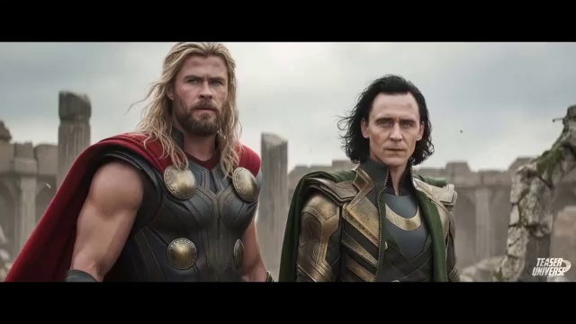
Transcript: Chaos is an old friend. Then let's greet it together. I will end this and begin again.
Scene Change: Visual content changed at this timestamp

55.6s
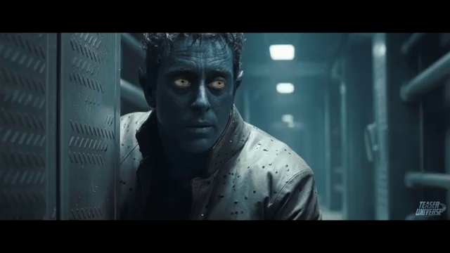
Transcript: Then let's greet it together. I will end this and begin again.
Scene Change: Visual content changed at this timestamp

56.5s
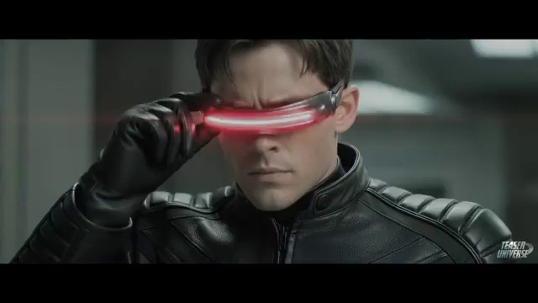
Transcript: I will end this and begin again.
Scene Change: Visual content changed at this timestamp

57.4s
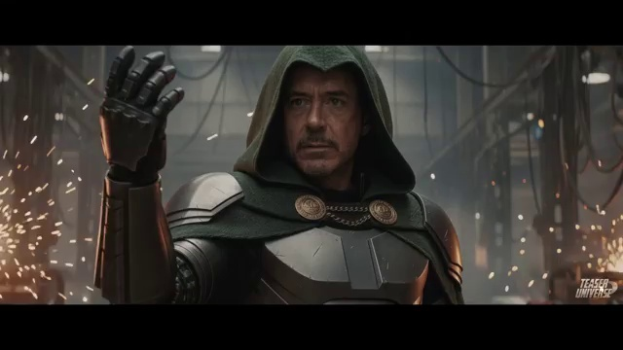
Transcript: I will end this and begin again.
Scene Change: Visual content changed at this timestamp

60.9s
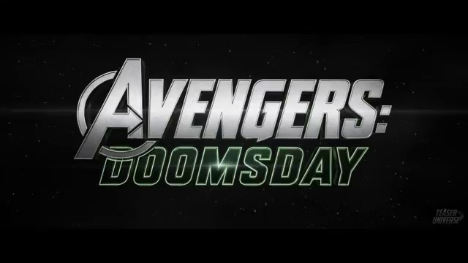
Transcript: [No speech at this timestamp]
Scene Change: Visual content changed at this timestamp

64.0s
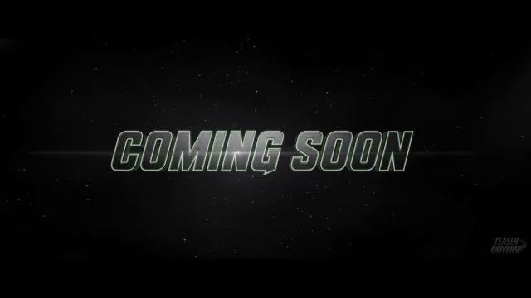
Transcript: [No speech at this timestamp]
Scene Change: Visual content changed at this timestamp

